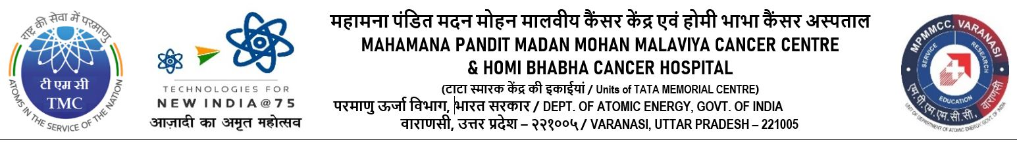

Date:- 06-04-2023

CORRIGENDUM

Refer to Open Tender for intends to hire Manpower Services MTS (Multi Tasking Staff- Unskilled Category). The tender HBCH/MPMMCC/HRD/TENDER/MTS/2023/01 published in the e-Publishing System (CPP Portal). Due to Administrative reasons, the following amendments have been done which details are given below:

Page no. & Point | EXISTING | TO BE READ AS
5 - Point no. d | Ten Crore two Lakh and turnover of last three years 2019-2020, 2020-2021 & 2021-2022 should be certified by Chartered Accountant. | Minimum turn over as of Rs. 09 Crore (Nine Crore) of last three years 2019-2020, 2020-2021 & 2021-2022 should be certified by Chartered Accountant.
6 - Point no. 10 of 4.1 | Bank Solvency certificate [Thirteen Crore Sixty Lakh(s) i.e. 40 percent of tender value] | Bank Solvency certificate “Nine Crore”
7 - Earnest Money Deposit | Bidders are required to deposit EMD amount (refundable) which will not bear any interest, must be paid by Demand Draft / Pay Order drawn in favor of ‘’Mahamana Pandit Madan Mohan Malviya Cancer Centre’’, payable at Varanasi only. | “The bid security may be added in the form of Account payee Demand Draft, Fixed Deposit Receipts, Banker’s cheque or Bank Guarantee from any of the Commercial Banks or Payment online in an acceptable form” in favor of ‘’Mahamana Pandit Madan Mohan Malviya Cancer Centre’’, payable at Varanasi only.
11 - Award of Contract | Selected bidder will be issued a letter of intent. Security deposit should be paid within 15 days. In case the selected bidder does not respond or is unable to complete formalities the EMD can be forfeited. A separate letter of intent /work order/Contract can be issued/executed for Homi Bhabha Cancer Hospital & Research Centre, Muzaffarpur, Bihar. | Selected bidder will be issued a letter of intent. Security deposit should be paid within 15 days. In case the selected bidder does not respond or is unable to complete formalities the EMD can be forfeited.  i. “ A separate letter of intent/ work order/ Contract can be issued/ executed for Homi Bhabha Cancer Hospital and Research Centre, Muzaffarpur, Bihar”
 |  | (P.T.O.)
 | (Page-2)
11 - Point No. (IV) of Award Criteria | The selected bidder shall give performance security deposit of 03% of Contract value in the form of Performance Bank Guarantee as per attached Annexure/ Demand Draft from a nationalized Bank or commercial bank or online payment in acceptable form for the duration of the contract/extended period, if any. On receipt of bank guarantee/ online payment towards security deposit the EMD of other bidders will be returned without any interest. Security deposit can also be submitted by way of a fixed deposit receipt in favour of Tata Memorial Centre. Additional performance security deposit should be given for the additional value of contract in case value of contract increases due to increase in the number of staff. The validity of the performance security deposit will be three months beyond the expiry of the contract period. | The selected bidder shall give Performance security should be 03% of the value of the Contract and may be furnished in the form of an Account payee Demand Draft, Fixed Deposit Receipts from a Commercial Banks, Bank Guarantee from a Commercial Banks or Online Payment in an acceptable form for the duration of the contract/extended period, if any. On receipt of bank guarantee/ online payment towards security deposit the EMD of other bidders will be returned without any interest. Security deposit can also be submitted by way of a fixed deposit receipt in favour of Tata Memorial Centre. Additional performance security deposit should be given for the additional value of contract in case value of contract increases due to increase in the number of staff. The validity of the performance security deposit will be three months beyond the expiry of the contract period.
36 - Sr. 5 of Annexure- XIII | Attested Copy Goods And Service Tax. | Attested Copy Goods And Service Tax and valid Bank Solvency certificate.

All other terms and conditions will remain the same.

Please visit TMC website www.tmc.gov.in & CPP Portal.

Dy. Administrative Officer (HRD)

